Software Requirements & System Design Specification (SRS/SDD)
Project Name: NeuroMEP - Connected MEP Design, Validation & Electrical Calculation Platform
Release Covered: Phase 1 - Electrical LV distribution, from the supply to the incoming feeder of each Distribution Board (DB)
Document Version: v0.3 - Freeze Candidate | 25 October 2026 (becomes v1.0 when the items in Section 18 marked "Blocking" are closed)
Prepared By: NeuroMEP Development Team
Target Environment: Web application (browser, desktop screens); hosting on Netcup VPS

0. Document Control
Version | Date | Change Summary
v0.1 | 21-Oct-2026 | Initial draft from CableSizer v1.1 (calculation file + manual), Components for NeuroMEP workbook, Project Set-up slide and UI screens.
v0.2 | 22-Oct-2026 | Independent verification of every calculation (Section 11) with corrected rules in Section 10; #TASK feature codes and error-code convention (Section 4); real-time multi-user collaboration with discipline greying (Section 8); tech stack and Netcup hosting (Section 7); component library from the POWER/LIGHT legend (Section 13); MAEC One and Revit future scope (Section 16); document condensed.
v0.3 | 25-Oct-2026 | Floor and building modelling combined on Page 2 with a Floor view / Building view toggle (riser on the left); pages renumbered 1-4; cable sizing runs on demand from the Cable Size button with live load table and Out-of-date marking (FR-18 to FR-30, Sections 7-10, D-20, D-21); new architecture diagrams in Section 7.

Source documents: CableSizer v1.1 Calculation File and User Manual; Components for NeuroMEP workbook; Project Set-up - Electrical slide; POWER/LIGHT legend sheet; NeuroMEP UI screens; IEC 60909-0, BS 7671, IEC 60364-5-52, IEC 60947-2.

1. Project Overview & Objectives
NeuroMEP is a web application for MEP (Mechanical, Electrical, Plumbing/PHE) design engineers. Engineers import floor plans, place components from a library by drag-and-drop, connect them by drawing cables (in the style of Cisco Packet Tracer), and the application calculates, sizes and validates every breaker and cable in a background engine when the engineer presses Cable Size, then produces the fixed-format panel schedules contractors build from. It replaces manual mark-up of floor plans and the spreadsheet calculation tool CableSizer.
Objective | What It Means
Eliminate manual calculation | Load summation, currents, breakers, cables, voltage drop, fault levels and earth-fault checks are calculated automatically from the drawn model.
Verified, standards-based results | Every formula is defined in Section 10 and verified in Section 11 against IEC 60909, BS 7671 / IEC 60364 and DEWA rules.
Connected model | Loads update instantly as you model; pressing Cable Size re-sizes every affected cable above and below a change (load, length, cable, new upstream panel).
Multi-discipline collaboration | Electrical, mechanical and PHE engineers work on the same floor at the same time with live sync, Google-Sheets style.
Safety rules enforced | Fire & life-safety (FLS), essential and critical loads checked for correct sources and fire-rated cabling along the whole path.
Traceability | Every feature has a #TASK code; every calculated value shows its inputs, table values and formula; every error carries a code.

Product Roadmap
Phase | Content
Phase 1 (this document) | Electrical LV distribution: transformer / generator / UPS -> LV panel / MDB -> busbar risers -> SMDB / MCC -> DB incoming feeder. DB is an end point with entered load.
Phase 2 | DB internal circuits and final circuits (lighting, sockets, small power) using the legend devices; mechanical and PHE layers editable with their own calculations.
Future | NeuroMEP as a sub-application of MAEC One; Revit connector and NeuroMEP-inside-Revit plug-in (Section 16).

2. Users, Roles & Discipline Layers
Role | Access | Responsibilities
Technical Lead / Project Admin | Full project access | Creates project, completes Project Set-up, assigns discipline engineers, overrides calculation defaults, approves issue.
Electrical Engineer (required) | Edit Electrical layer | Places electrical components, draws cables, enters DB loads, reviews results, locks sizes, exports schedules.
Mechanical Engineer (optional in Phase 1) | Edit Mechanical layer | Places mechanical equipment and enters its electrical data (kW, phases, pf, load category) which feeds the electrical model.
PHE Engineer (optional in Phase 1) | Edit PHE layer | As above for pumps, fire pumps and PHE equipment.
Checker / Reviewer | Read + comment | Verifies results and signs revisions.
System Administrator | Reference data, users | Maintains rule packs, lookup tables, breaker catalogue, demand-factor defaults, component library and symbols.

Discipline layers: each component belongs to one discipline layer. A user can edit only the layers of their discipline; other layers are visible but greyed out and read-only, and update live as their owners work (Section 8). Authentication sits behind a provider interface so that MAEC One unified login can be plugged in later (Section 16).

3. Scope & Electrical Hierarchy
Level | Equipment | Fed From | Feeds
L0 Supply | EB Utility / RMU (HV) | Grid (fault level input) | Transformer
L1 Source | Transformer; Generator via ATS; UPS for critical loads | RMU / ATS / panel | LV Panel / MDB
L2 Main distribution | LV Panel, MDB, ACB panel, EMDB | Transformer / ATS | Busbars, SMDBs, MCCs, PFC bank, isolators, DBs
L3 Riser | Busbar (feeder or tap-off type), tap-off boxes | MDB | SMDBs, DBs
L4 Sub-main | SMDB, ESMDB, MCC, EMCC | MDB / tap-off box | DBs, isolators, motors
L5 Terminal (Phase 1 end) | DB, isolator, connection unit | SMDB / MCC / MDB | Not modelled in Phase 1 (load entered as totals)

Element | Allowed Upstream | Allowed Downstream | Rules
Transformer | RMU | LV Panel / MDB / feeder busbar | 4P incomer
Generator / ATS | Generator: none; ATS: normal + standby input | ESMDB / LV Panel | ATS has exactly two inputs and one output
LV Panel / MDB | Transformer, ATS | Busbar, SMDB, MCC, DB, PFC, UPS, isolator | Max 25 ways, warning above 18; up to 2 incomers
Busbar feeder / tap-off | MDB | Feeder: one panel; tap-off: tap-off boxes only | Tap-offs only on tap-off type
SMDB / MCC | MDB, tap-off box | DB, isolator, connection unit, motors | As panel
DB, isolator, connection unit | SMDB, MDB, MCC, tap-off, UPS | - (Phase 2) | Terminal in Phase 1

The network is radial (no loops); each element has exactly one active supply per scenario; single-phase elements take one phase of a three-phase panel (automatic allocation with manual override).

4. Feature Task Codes & Error-Code Convention
Every feature has a permanent code #TASK-nn. The code is used in requirement IDs, backlog tickets, branch names and commit messages (e.g. "#TASK-22 fix single-phase r/x lookup"), test names, log lines and error codes, so any failure can be traced to its feature in seconds. Codes are never reused or renumbered; retired features keep their code with status "Retired".
Code | Feature | Page / Layer | FRs
#TASK-01 | Authentication, session, roles | Login | FR-01
#TASK-02 | Project picker (list, create, import) | After login | FR-02
#TASK-03 | Project details & site conditions | Page 1 | FR-03
#TASK-04 | Calculation set-up, region, demand factors, defaults panel | Page 1 | FR-04, FR-05
#TASK-05 | Floor registry & elevations | Page 1 | FR-06
#TASK-06 | Floor-plan upload & viewer | Page 1 | FR-07
#TASK-07 | Scale calibration & plan replacement | Page 1 | FR-08, FR-09
#TASK-08 | Project persistence, autosave, versioning, optimistic locking | API | FR-10
#TASK-09 | Real-time sync & presence | All modelling pages | FR-11
#TASK-10 | Discipline layers, greying, element locks | All modelling pages | FR-12
#TASK-11 | Component library & legend symbols | Page 2 | FR-13
#TASK-12 | Placement & auto-tagging | Page 2 | FR-14
#TASK-13 | Cable drawing, routing & length | Page 2 | FR-15
#TASK-14 | Topology rules & connection validation | Page 2 | FR-16
#TASK-15 | DB / equipment load entry | Page 2 | FR-17, FR-35
#TASK-16 | Right panel: load table, Cable Size & results | Pages 2-3 | FR-18, FR-36
#TASK-17 | Building view: floor stack & riser (3D later) | Page 2 | FR-19
#TASK-18 | Risers, sources, ATS, network completeness (Building view) | Page 2 | FR-20
#TASK-19 | Engine: load aggregation & demand factors | Engine | FR-21
#TASK-20 | Engine: design current & protective devices | Engine | FR-22
#TASK-21 | Engine: current-carrying capacity & derating | Engine | FR-23
#TASK-22 | Engine: voltage drop | Engine | FR-24
#TASK-23 | Engine: short-circuit (max, min, peak, withstand) | Engine | FR-25
#TASK-24 | Engine: thermal withstand (let-through) | Engine | FR-26
#TASK-25 | Engine: earth-fault loop & disconnection | Engine | FR-27
#TASK-26 | Engine: auto-sizing on Cable Size, provisional mode | Engine | FR-28
#TASK-27 | Engine: scenarios & safety-category rules | Engine | FR-29
#TASK-28 | Engine: PFC, generator, transformer loading, tray | Engine | FR-30
#TASK-29 | Reference data, rule packs & admin | Admin | FR-31
#TASK-30 | Single-line diagram, schedule grid, overrides | Page 3 | FR-32
#TASK-31 | Scenario review, exports & output versioning | Page 4 | FR-33
#TASK-32 | Audit log, error logging & monitoring | API | FR-34
#TASK-33 | Revit connector (future) | Revit add-in | Section 16
#TASK-34 | MAEC One integration (future) | Platform | Section 16

Error & Log Code Convention
- Error code: E + task number (2 digits) + sequence (2 digits), e.g. E2203 = third error of #TASK-22 (voltage drop). Each code is listed once in the code catalogue (`packages/shared/errors`) with message, severity and suggested action. Appendix D lists the 22 errors engineers will meet in normal use.
- Calculation check codes: C1-C12 (Section 10.12) identify which check failed on an element; they appear in the properties panel, schedules and reports.
- Log line format: `[timestamp] [level] [#TASK-nn] [Ennnn] message {projectId, floorId, elementTag, userId, rulePackVersion}`. Levels: DEBUG, INFO, WARN, ERROR. The user sees the message and code; support sees the full context.
- Engine trace: every engine run carries a run ID; each element result stores the run ID, rule-pack version and the codes of checks evaluated, so a reported result can be replayed exactly.

5. Functional Requirements
ID | Task | Pri. | Requirement
FR-01 | #TASK-01 | High | Sign-in with email and password behind an AuthProvider interface (dev provider now, MAEC One later); masked password with show/hide; generic error message; session persists across reloads; protected routes; "Demo credentials" shown only in development builds.
FR-02 | #TASK-02 | High | After login, a project picker lists accessible projects (name, client, stage, revision, last modified); Technical Lead can create a project; any user can import a project file (.json).
FR-03 | #TASK-03 | High | Capture project details and site conditions (Section 12.1) with inline validation; region defaults tagged as such.
FR-04 | #TASK-04 | High | Region selection loads the rule pack (Dubai active; others disabled). Calculation check-boxes decide which checks are calculated: a check that is not ticked is not calculated at all and is shown "Not calculated - not selected on Page 1" in the right panel, schedules and reports. Ampacity is always calculated because cable sizing depends on it; the other checks are ticked by default when a project is created. Read-only "Calculation defaults" panel (12.2), overridable by the Technical Lead with audit.
FR-05 | #TASK-04 | High | Demand-factor tables (12 load types; Residential/Landlord/Office/Retail) pre-filled from the rule pack, editable per project and per panel; unknown values shown as "TBC", never invented.
FR-06 | #TASK-05 | High | Floor registry generated from floor counts (B1..Bn, GF, P1..Pn, typical, mechanical tags); GF datum level, floor-to-floor heights and cumulative levels; changing counts never deletes floors with plans without confirmation.
FR-07 | #TASK-06 | High | One PDF plan per floor (single page, up to 20 MB), stored on the server and converted once into a plan image for the screen (image tiles in Phase 1); the browser loads only the open floor, with zoom, fit and pan; plan status No plan / Uncalibrated / Calibrated. The model is stored in metres, so the plan is a background only (Section 7, Floor-Plan Handling).
FR-08 | #TASK-07 | High | Two-point scale calibration (or drawing-scale entry, marked less reliable) stored in PDF coordinates as metres per drawing unit; optional verify measurement; lengths are not calculated on uncalibrated floors.
FR-09 | #TASK-07 | Med. | Replacing a plan keeps the model, requires re-calibration and alignment to the previous plan by a common reference point, recalculates lengths, and flags components outside the new extents.
FR-10 | #TASK-08 | High | Projects saved in the database and exportable/importable as .json (schemaVersion, rulePackId/version); autosave; undo/redo of own actions; optimistic locking by element version.
FR-11 | #TASK-09 | High | Real-time collaboration: every change by any user appears for all users on the same project within 1 second, with presence (who is on which floor) and selection highlights (Section 8).
FR-12 | #TASK-10 | High | Discipline greying: components and library tabs of other disciplines are greyed out and read-only; an element being edited by another user shows that user and is locked until released.
FR-13 | #TASK-11 | High | Bottom component library with tabs All / Electrical / Mechanical / PHE using the company legend symbols (Section 13); Phase 2 items visible but disabled.
FR-14 | #TASK-12 | High | Drag-and-drop placement with automatic equipment tags (Section 12.4).
FR-15 | #TASK-13 | High | Port-to-port cable drawing with orthogonal multi-point routing; length = routed length x scale + vertical runs + length allowance. Drawing from a panel creates an outgoing way with circuit reference (1RYB, 2R...). Cable construction is chosen while drawing (project defaults); size is never picked by the user.
FR-16 | #TASK-14 | High | Topology rules of Section 3 enforced on connect; illegal connections refused with message and code.
FR-17 | #TASK-15 | High | DB load per phase and load type, or area x W/m2 per phase, with load category, demand category and power factor; mechanical/PHE equipment supplies kW, phases, pf, efficiency and starter type. Panels (LV Panel / SMDB / ESMDB), tap-off boxes, isolators and connection units also accept manual load per load type (kW or area x W/m2) for outgoing ways not connected to equipment, and every load point carries a standby load (kW), acquired from downstream or entered where not connected (10.3).
FR-18 | #TASK-16 | High | Right-hand panel: a load table always shows connected and maximum-demand load of the selected element and its floor, updated instantly as components and loads are added. Pressing the Cable Size button runs the engine and shows size, runs, ECC, breaker, Ib/In/Iz, voltage drop (own and total, 2 decimals), fault levels, each check, status Provisional/Final, the deciding check ("Sized by"), lock buttons and the full calculation trace. The load table is always displayed on the right side of Pages 2 and 3; it lists every component of the floor (or below the selected panel) with load type, kW per phase (L1 / L2 / L3), power factor and current, with connected and maximum-demand totals, and refreshes on every add, edit or delete without pressing Cable Size.
FR-19 | #TASK-17 | High | Floor modelling and building modelling share Page 2. A button in the top-right corner switches between Floor view (plan of one floor) and Building view (all floors stacked by elevation with the riser drawn on the left connecting them). Both views use the same model, right-hand panel and selection. A 3D isometric view follows in Phase 1 completion.
FR-20 | #TASK-18 | High | In Building view: risers (busbar or cable) on the left connect the floors, with a tap-off per floor and lengths from elevations; connection of risers, MDB, transformer, generator via ATS, UPS, PFC; network completeness validation.
FR-21 to FR-30 | #TASK-19 to 28 | High | Calculation engine as specified in Section 10: a background service with no page. Cable sizing runs only when the user presses Cable Size in the right-hand panel (selected element, current floor or whole project) and automatically before export; later changes mark affected results "Out of date" until Cable Size is pressed again. Load totals, topology rules and missing-data checks stay live. Unlocked items re-solved from minimum size each run; locked items validated only; all failing checks reported.
FR-31 | #TASK-29 | High | Versioned rule packs and lookup tables with reference conditions, edited only by the System Administrator with audit; a project records the version it used.
FR-32 | #TASK-30 | High | Page 3 Architecture: single-line diagram and schedule grid in the formats of Section 14; only input cells editable; edits synchronised with the canvas; locks and per-panel demand-factor overrides.
FR-33 | #TASK-31 | High | Page 4 Simulation & Report: normal and standby scenarios, final check list (failures, warnings, Not calculated, overrides), exports in Excel/PDF with title block; files never overwritten (_v1, _v2).
FR-34 | #TASK-32 | High | Structured logging with task and error codes (Section 4); audit of set-up, demand-factor, default and lock changes.
FR-35 | #TASK-15 | High | DB loads can be uploaded from an Excel sheet (NeuroMEP template): one row per DB name with load per load type per phase (kW) or area and W/m2. Rows are matched to DBs by tag; a preview shows matched rows, unmatched rows (E1503) and changed values before import. Imported values stay editable and the import is written to the audit log.
FR-36 | #TASK-16 | Med. | Hovering over any element shows a tooltip with its key data (12.5). Calculated values come from the last Cable Size run and are marked "Out of date" when stale; voltage drop to 2 decimals.

6. Non-Functional Requirements
Area | Requirement
Performance | Load table updated within 0.5 s of an edit; a Cable Size run for a 2,000-element building completes within 2 s; collaboration updates visible to other users within 1 s. Memory on the engineer's PC: browser tab at most 400 MB with a project open and no floor loaded (static), and at most 1.2 GB with a 2,000-element floor and its plan open during a Cable Size run (dynamic). Server stays within the RAM budget of Figure 7.4 with 10 active users. Both are measured in a load test before go-live and recorded in a capacity report.
Calculation accuracy | Continuous results within +/-0.5 % of the hand-checked reference project; discrete selections identical. No result is produced from a missing or out-of-range table value - the element is blocked with a code.
Determinism & traceability | Same model + rule-pack version = identical results on every client and the server; every result replayable from its run ID.
Concurrency | At least 10 simultaneous users per project without conflicts or lost edits. Engineers edit only the floors assigned to them by the lead engineer; two engineers on the same floor are kept apart by discipline greying and element locks (Figure 7.3). Checked by a test with two browsers per role.
Reliability | Autosave; no more than 1 minute of work lost on browser failure; daily database backups on the VPS with off-site copy. Autosave every 10 s; availability 99.5 % during working hours; the API restarts automatically and clients reconnect without losing edits; monthly restore test of the backup; calculation reliability proven by the independent checker and the reference project (Section 11).
Security | Role- and discipline-based access; HTTPS; httpOnly session cookies; audit log; project data stays on company infrastructure. Floor-level access, login attempt limits and safe plan upload (Figure 7.3). Cyber security testing: OWASP ZAP scan and manual OWASP Top 10 checks before go-live and after major releases; every finding rated and closed before release.
Usability & compatibility | Plain-language messages with codes; colour always paired with text; latest Chrome/Edge; minimum 1920 x 1080. Voltage drop is always shown to 2 decimal places (right panel, schedules, reports).
Maintainability | Engine is an isolated TypeScript package with pure functions and full unit tests (Appendix C vectors). Code analysis on every push (ESLint security rules, CodeQL / Semgrep, npm audit) with a test-coverage report (engine at least 90 %); a code analysis report is issued with each release.

7. System Architecture & Technical Stack
Layer | Responsibility
01 Presentation | Login, project picker, Pages 1-4 (Page 2 with Floor / Building views), right-hand panel with load table and Cable Size, schedule grid.
02 Application controller | Project state and undo/redo; canvas viewport (pan, zoom, fit to screen, grid, snap, plan-tile loading); selection and editing (multi-select, move, copy/paste, delete, keyboard shortcuts); autosave; Floor / Building view switch; discipline locks; collaboration client; dispatch of Cable Size requests to the engine worker. Cable lengths are measured in the network model (03) from the calibrated plan and floor heights, not by the engine (FR-15).
03 Network model | Graph of nodes (sources, panels, busbars, tap-offs, DB end points) and edges (cables, busbar runs); topology rules; tags; lengths.
04 Calculation engine | Background service, no page; runs when Cable Size is pressed and before export: aggregation, Ib, devices, ampacity, voltage drop, faults, withstand, earth-fault, auto-size, scenarios. Same package runs in a browser Web Worker and on the server.
05 Reference data | Versioned rule packs and lookup tables with reference conditions.
06 Persistence, sync & export | REST API, real-time socket server, MongoDB, file storage, exports.

Area | Choice (D-14)
Repository | One TypeScript repository with npm workspaces: apps/web, apps/api, packages/engine, packages/shared, packages/rulepacks; revit-addin/ (future, C#).
Front end | React + TypeScript (Vite); Zustand state; Konva canvas; PDF.js for plans; three.js for the 3D view; Zod forms; Socket.IO client; engine in a Web Worker.
Back end | Node.js (current LTS) + Express in TypeScript; Socket.IO for real-time sync and presence; Zod validation shared with the front end.
Database | MongoDB as a replica set (needed for transactions and change streams) with the official driver; collections: projects, floors, elements, rulepacks, auditLog, exports, sessions. PDFs and exports in GridFS (object storage later).
Calculation engine | packages/engine - pure TypeScript, no UI or database imports; identical results in browser and server.
Exports | ExcelJS for schedules; HTML-to-PDF renderer for reports (library chosen at implementation).
Testing & quality | Vitest (unit), mongodb-memory-server (database), Playwright (end-to-end, collaboration with two browsers); ESLint + Prettier; CI on every push.
Hosting | Netcup VPS: Nginx reverse proxy with HTTPS (WebSocket upgrade enabled), Node API under PM2 or Docker, MongoDB replica set on the VPS (or Atlas), nightly backups; staging and production environments.
Future | Revit add-in in C# .NET (Section 16); MAEC One authentication via the AuthProvider interface.

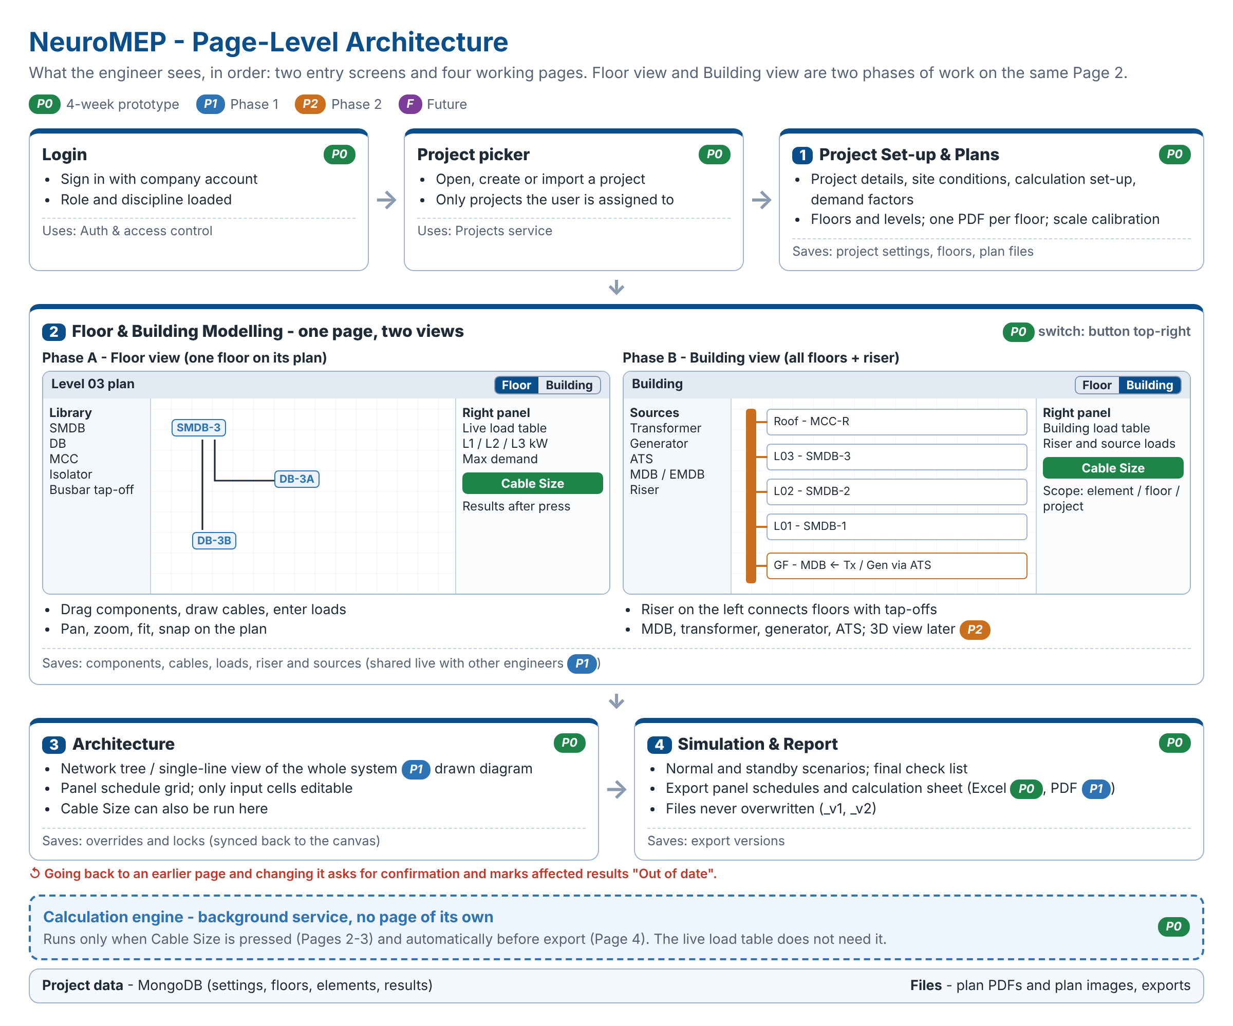
Figure 7.1 - Page-level architecture: login, project picker and Pages 1-4; Page 2 holds Floor view and Building view

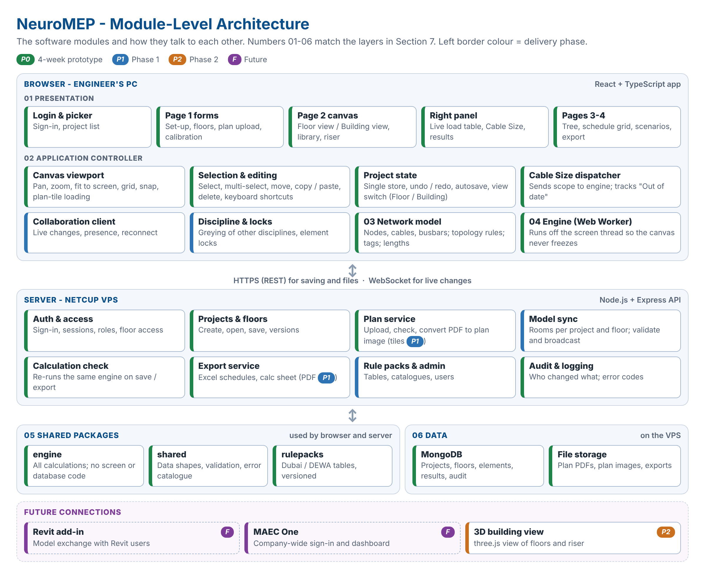
Figure 7.2 - Module-level architecture: browser layers 01-04, server modules, shared packages and data

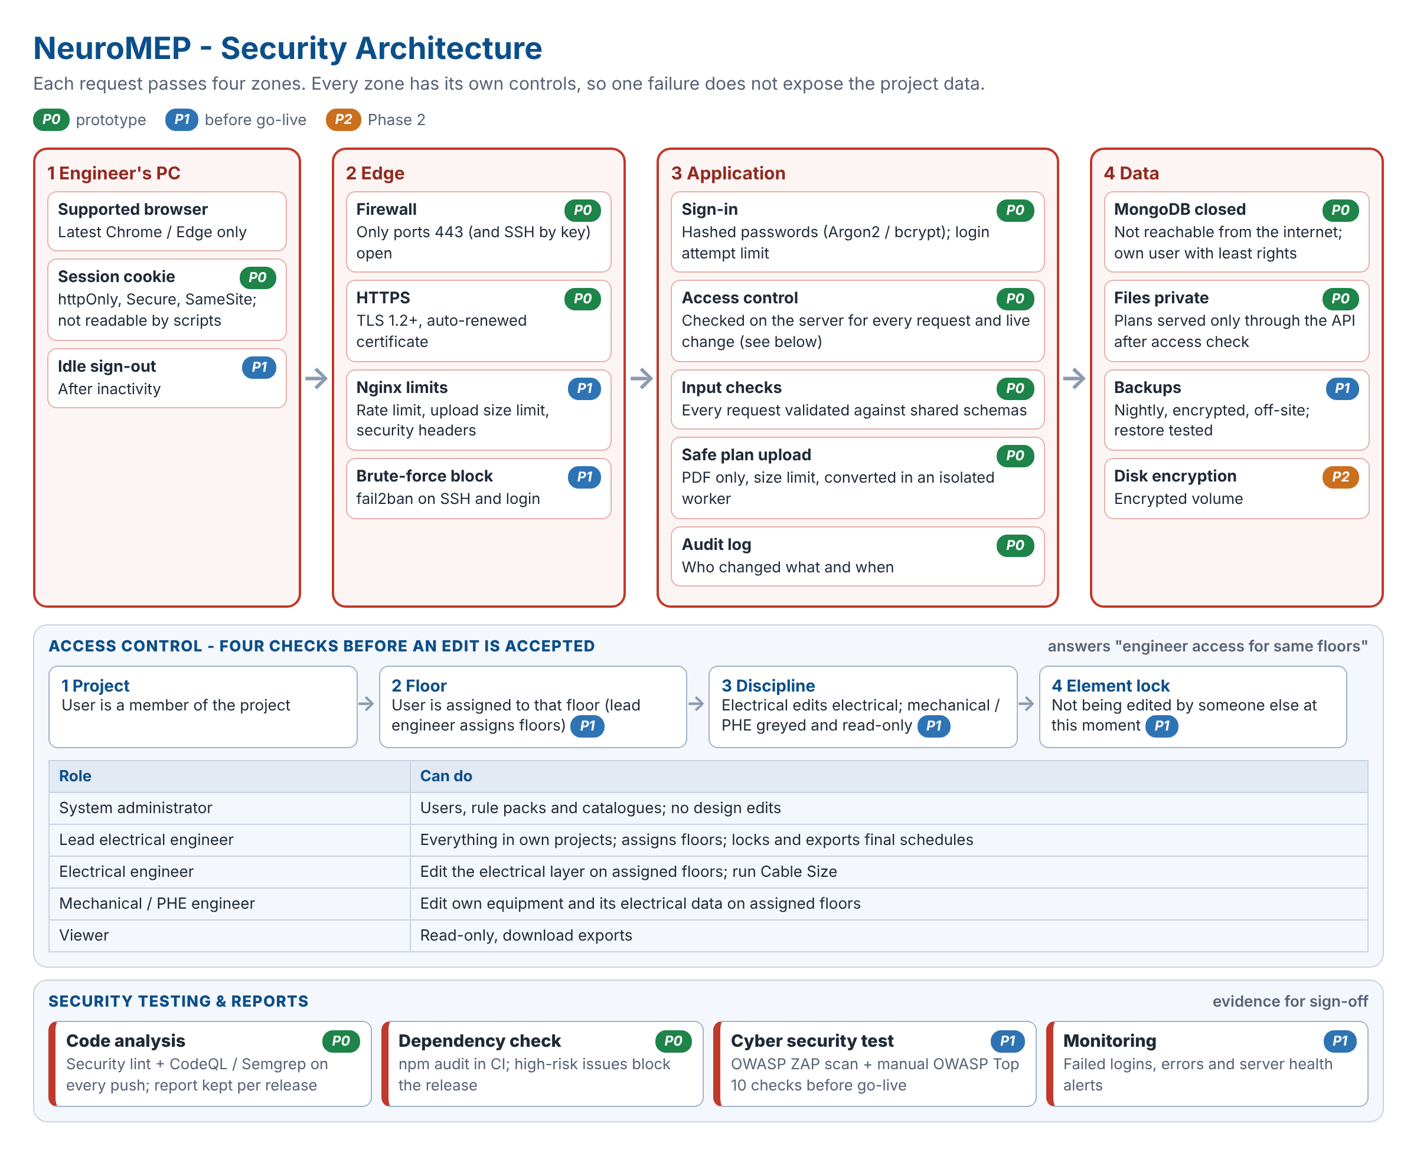
Figure 7.3 - Security architecture: controls in four zones, access checks by project, floor, discipline and element, and security testing

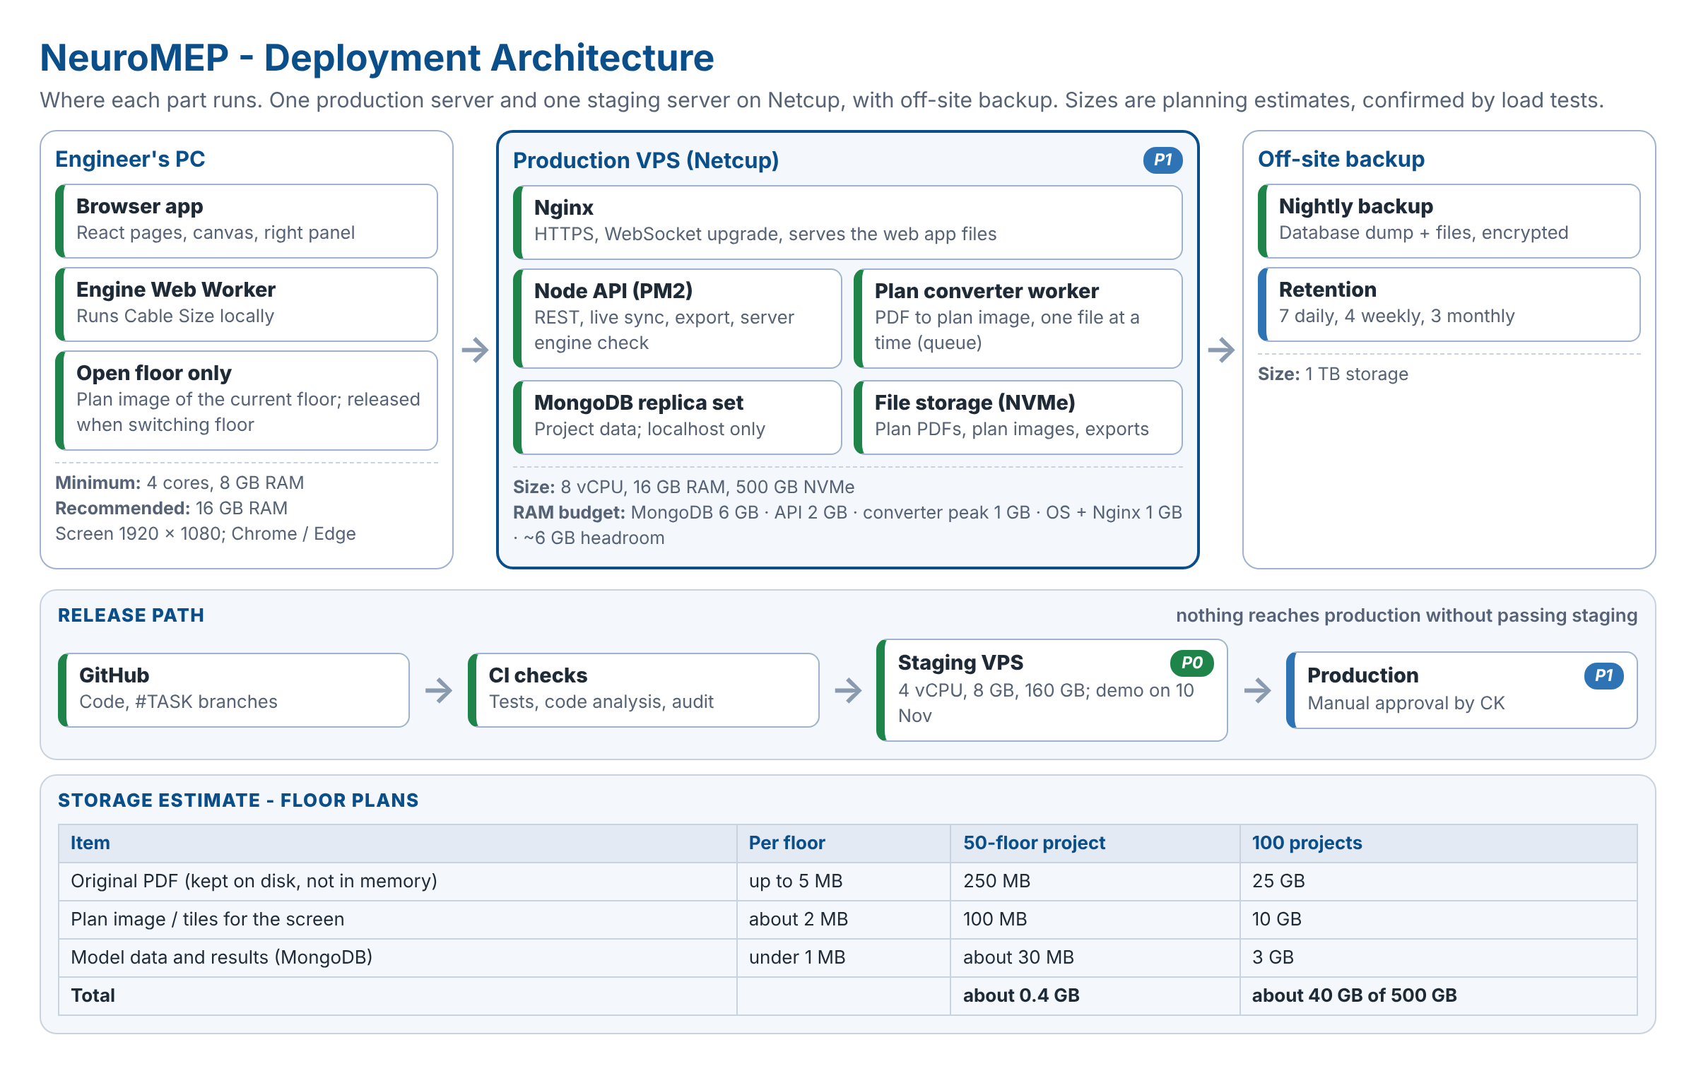
Figure 7.4 - Deployment architecture: engineer PC, Netcup production and staging servers, backup, release path and storage estimate (planning figures, confirmed by load tests)

Floor-Plan Handling & Memory
Step | Design
Upload | One single-page PDF per floor, up to 20 MB. The file is streamed straight to disk; the server never holds the whole file in memory. Type and size are checked before it is accepted.
Conversion | A background worker converts each PDF once into a plan image (P0) or image tiles at several zoom levels (Phase 1), one file at a time from a queue, so 50 uploads wait in line instead of using 50 times the memory. Text labels (room names) and their positions are extracted at the same time, so a component's location / room can be suggested from the nearest label; the engineer can change it. Not available for scanned PDFs without text.
Display | The browser loads only the plan of the floor that is open. With tiles, only the part on screen is loaded. Switching floor releases the previous plan. Building view needs no plans.
Model independence | Components and cables are stored in real-world metres after calibration, not in PDF pixels. Calculations and exports never read the PDF, so a plan can be replaced or removed without losing the model.
Keeping originals | Original PDFs stay on disk (not in memory) for the life of the project: plans are revised after outputs are issued, calibration may be redone and the audit trail needs them. A replaced plan is kept 30 days, then deleted.
Clean-up | When a project is archived, its plan files move to off-site backup and are removed from the server. The administrator can purge originals of closed projects.
Size | About 0.4 GB for a 50-floor project (originals 250 MB, plan images about 100 MB, model data about 30 MB); about 40 GB for 100 projects on a 500 GB server (Figure 7.4).

8. Real-Time Collaboration Design
Several engineers (for example electrical and mechanical) can work on the same project and the same floor at the same time. Every change appears for everyone almost immediately, like Google Sheets, and nobody can overwrite another discipline's work.
Topic | Design
Channels | Each open project is a Socket.IO room; each floor a sub-room. Clients send operations (add, move, delete, connect, edit property); the server validates permission and version, stores the change in MongoDB and broadcasts it to the room. The server is the single source of truth.
Discipline greying | Each element and library tab belongs to a discipline layer. For an electrical engineer, mechanical and PHE elements and tabs are greyed out and read-only (and vice versa); they still move, appear and disappear live as their owners work.
Presence | Avatars show who is on which floor; each user's current selection is outlined in their colour with their name.
Element locks | Selecting an element for editing takes a soft lock: other users see it greyed with "Being edited by <name>". The lock is released on deselect, after 60 s idle, or on disconnect.
Conflicts | Every element carries a version number; an operation based on an old version is rejected (E0902) and the client reloads that element. Locks make this rare.
Cross-discipline data | When a mechanical engineer changes an AHU's kW, the electrical model updates for everyone and affected cables are marked "Out of date" until Cable Size is pressed; the electrical engineer gets a notice listing the changed elements.
Calculation consistency | Cable Size results are stored with their run ID and shared with every user; each client runs the same engine and rule-pack version, so all users see identical results; the server re-runs the engine on save/export and logs any mismatch (E2690).
Disconnection | On connection loss the canvas becomes read-only with a "Reconnecting" banner; after reconnection missed operations are replayed. No offline editing in Phase 1.
Undo / redo | Per user, own operations only.
Scaling | One API instance is sufficient for Phase 1; a Redis adapter for Socket.IO is added if the API is scaled to several instances.

9. Pages & End-to-End Workflow
Page | Purpose | Main Steps | Exit Condition
Login | Authenticate | Email + password; roles loaded. | Valid session
Project picker | Choose or create project | Open, create (Technical Lead) or import .json. | Project selected
1 Project Set-up & Import Floor Plan | Project data, calculation set-up, floors, plans | Details and site conditions; region, fault level, checks, demand factors; floor counts -> registry with levels and heights; working directory; discipline assignment; PDF per floor and calibration. | Required fields valid; registry complete; at least one floor calibrated
2 Floor & Building Modelling | Model each floor, then the building | Floor view: place components, draw cables (construction only), enter DB and equipment loads; the load table updates live. Building view (top-right toggle): floors stacked with the riser on the left connecting them; connect tap-offs, MDB, transformer, generator (ATS), UPS, PFC. Press Cable Size in the right-hand panel to size cables and run all checks (Provisional until the path reaches a source). | No unconnected components or rule violations on the floor Changing an earlier page asks for confirmation first (see "Changes to earlier pages" below this table).
3 Architecture | Review and override | Single-line diagram; schedule grid; lock sizes; per-panel demand factors; phase allocation. Cable Size can also be run from here. | Reviewed
4 Simulation & Report | Issue | Standby (generator) scenario; final check list; exports with title block and versioned names. | Issued
Changes to earlier pages. When the engineer goes back and changes an earlier page (for example ambient temperature or demand factors on Page 1, or a floor height), a confirmation message lists what will be affected (floors, panels, cables) before the change is saved. On "Confirm" the change is saved and affected results are marked "Out of date" until Cable Size is pressed; on "Cancel" nothing changes. Every confirmed change is written to the audit log.

10. Electrical Calculation Specification (Verified)
This section defines the engine. It follows the CableSizer method where that method was verified correct, and applies the corrections found in the independent verification (Section 11, items V-nn). Items marked [ENG] need confirmation by the Senior Electrical Engineer before v1.0.

10.1 Conventions
Item | Rule
Units | V (400 three-phase / 230 single-phase), A, kW, kVA, kVAr, mOhm (per metre: mOhm/m), kA, mm2, m, deg C, K.m/W. Full precision internally; rounding only for display (currents 1 dp, % 2 dp, kA 2 dp, mOhm 3 dp).
Voltage factor (V-03) | Maximum fault currents use cmax = 1.10; minimum fault currents use cmin = 0.95 (BS 7671 Cmin for Zs) - DEWA declares 230/400 V +/-10 %. [ENG]
Missing data | A missing, blank or out-of-range table value never becomes 0 or 1: the element is blocked with an error code (V-14).
Between table steps | Temperature, soil resistivity and depth factors are interpolated linearly inside the table range; outside the range the element is blocked. [ENG]

10.2 Calculation Order (runs when Cable Size is pressed)
1. Identify supply paths; elements without a path to a source run in Provisional mode (10.13). 2. Pass 1 (bottom-up): connected load per phase and load type, demand factors, maximum demand. 3. Ib for every cable and busbar run; device selection. 4. Starting cable size: locked size, else the regional minimum for the breaker. 5. Pass 2 (top-down): impedances, maximum and minimum fault currents, peak current, cumulative voltage drop, earth-fault loop. 6. Checks C1-C12 on every element; upsize failing unlocked cables; repeat steps 3-6 until nothing changes (all checks re-run each iteration, because a larger upstream cable raises downstream fault levels). 7. Standby scenario and ancillary results. The right-side load table (FR-18) uses step 2 only and updates live; the full procedure runs when Cable Size is pressed.

10.3 Load Aggregation & Demand Factors
DB: connected load per phase and load type (entered, or area x W/m2). Panel: connected load = sum of downstream connected loads per phase and type; demand = connected x demand factor of the type, applied once at each panel to the downstream connected load (factors are never multiplied down the tree); maximum demand = sum over types. How load-type and category factors combine is open (OI-02). Transformer MD = MD of the panels it feeds; generator MD calculated per standby scenario (10.14). Manual loads: where a panel, tap-off box, isolator or connection unit has outgoing ways not connected to equipment, the engineer enters their load per load type (kW or area x W/m2); connected downstream loads are always acquired, so a manual entry covers only the unconnected part and is never added twice [ENG]. MCC / EMCC load is always the sum of the downstream equipment (no manual entry). Several demand categories: an LV Panel / SMDB / ESMDB or MCC / EMCC may carry several demand categories (residential, landlord, office, retail); each downstream load keeps the category of its DB or isolator and the demand factor is applied per category subtotal (OI-02) [ENG]. Standby load (kW) is acquired from downstream equipment or panels, or entered where nothing is connected, and is the load used in the standby scenarios.

10.4 Design Current Ib
Case | Rule
Three-phase balanced | Ib = P x 1000 / (sqrt3 x 400 x pf)
Single-phase (L-N) | Ib = P x 1000 / (230 x pf)
Line-to-line load (V-04) | Ib = P x 1000 / (400 x pf). The legacy "two-phase" formula is removed; the connection type is modelled explicitly.
Panel / feeder with unbalanced phases (V-05) | Ib = largest phase current = max(P_phase x 1000 / (230 x pf)); neutral current reported.
Motor (V-06) | Ib = P_out x 1000 / (sqrt3 x 400 x pf x efficiency), or nameplate full-load current if entered. Default efficiency by motor class. [ENG]
Star-delta starter (V-07) | Supply cable and breaker: line current as above. Two motor-side cable sets: line current / sqrt3. Overload relay set at 0.58 x full-load current.
Capacitor (PFC) bank (V-08) | Ib = 1.5 x Q x 1000 / (sqrt3 x 400) (minimum factor 1.43, IEC 60831); detuned banks use the manufacturer factor. The legacy division by sin(phi) is removed.

10.5 Protective Devices
Item | Rule
Rating | Ib <= In <= Iz (BS 7671 433.1.1). In = lowest standard rating >= Ib (Appendix B); for adjustable trip units In = the Ir setting. Breakers in panels at 50 deg C are derated per manufacturer (V-22).
Type & poles | MCB/MCCB below 800 A, ACB at 800 A and above; MCP for motors. 1P single-phase, 3P three-phase, 4P sources and main incomers.
Magnetic threshold Im (V-09) | Taken from the breaker catalogue for the selected trip unit and setting (OI-03). The legacy rule "Im = n x frame" is removed. For checks use Ia = 1.2 x Im (IEC 60947-2 +/-20 % tolerance) unless the manufacturer states another tolerance.
Breaking & making capacity (V-10) | Icu (or Ics if specified) >= maximum Ik at the panel where the breaker is installed; Icm >= peak current ip. Available fault ratings (components sheet): MCB 6 / 10 / 16 / 25 kA; MCCB 25 / 36 / 50 / 65 kA; ACB 50 / 65 / 85 kA. The engine selects the lowest available rating >= Ik"max; if the device type has no sufficient rating it moves to the next type (MCB -> MCCB -> ACB); above 85 kA the element fails C3 with E2002 [ENG]. Device type is a dropdown (MCB / MCCB / ACB; ACB auto-selected at 800 A and above); panel incomers may also be an isolator.
Earth leakage | 30 mA / 100 mA ELCB, 0-300 / 0-500 mA ELS - shown in Remarks. Selected on DB and LV Panel / SMDB / ESMDB, on isolators and on tap-off boxes; an isolator connected to a load takes it from the load and it is shown in the Remarks of the panel feeding that isolator; MCC / EMCC outgoings take it from the downstream isolators. Used by the earth-fault loop rule (10.10).

10.6 Current-Carrying Capacity (C1)
Iz = It x K1 x K2 (x Kr x K3 for buried) x number of runs; pass if Iz >= In. Every rating table is stored with its reference conditions (air temperature, ground temperature, soil resistivity, depth, installation arrangement) and derating factors are taken only from tables with the same reference (V-11). The CableSizer ampacity tables contain data errors (method B equal to free air, 300 mm2 rated below 240 mm2, single-core columns spliced and buried single-core copied from four-core) and must be replaced by verified manufacturer (Ducab) or BS 7671 Appendix 4 tables before release (V-12, OI-07). Grouping factors outside the tabulated range (e.g. more than 3 trefoil circuits) block the result (V-13). Parallel runs must be identical in type, length and arrangement; otherwise an unequal-sharing derating applies (V-23).

10.7 Voltage Drop (C2)
Unit drop Vu = r x cos(phi) + x x sin(phi) (mV/A/m), with r and x taken from tables keyed by phases, cores, arrangement (trefoil / flat / spaced), insulation and size (V-15); single-phase values are the two-conductor values (= 2/sqrt3 x three-phase). Circuit drop Vc = Ib x L x Vu / (1000 x runs); cumulative Vt = Vc + upstream Vt; %Vt = Vt / Vn. Busbars use R and X per metre with the load power factor (V-16). Cumulative limits (Dubai rule pack): MDB, SMDB, busduct, MCC 2.0 %; DB 2.5 %; motors and final circuits 4.0 % (DEWA 4 % total).

10.8 Short-Circuit Current (C3) - IEC 60909
Element | Impedance (mOhm)
Upstream network (V-17) | ZQ = cQ x Vn^2 / (S"kQ x 1000), cQ = 1.1; XQ = 0.995 ZQ; RQ = 0.1 XQ. DEWA maximum S"k for duty checks, minimum for protection checks.
Transformer (V-18) | ZT = uk x Vn^2 / (S x 100); RT = ur x Vn^2 / (S x 100); XT = sqrt(ZT^2 - RT^2); multiplied by KT = 0.95 x cmax / (1 + 0.6 xT). uk, ur from datasheet; default uk = IEC 60076-5 minimum (<=630 kVA 4 %, 631-1250 5 %, 1251-2500 6 %, 2501-6300 7 %).
Generator (V-19) | Maximum: X"d with RG = 0.15 X"d and KG (IEC 60909). Minimum (protection checks on standby supply): the sustained short-circuit current from the generator datasheet.
Cable (V-20) | R from IEC 60228 resistance at 20 deg C per size / runs (maximum); at end-of-fault temperature for minimum. X from the manufacturer per arrangement (typical multicore 0.08, trefoil 0.085, flat 0.095 mOhm/m).
Busbar | R and X per metre from the busbar manufacturer datasheet.
Motor group (V-21) | ZM = Vn^2 / (IL/IF x SrM); XM = 0.922 ZM; RM = 0.42 XM (IEC 60909; the CableSizer sheet was right, the manual wrong). SrM = sum P / (efficiency x pf). Combined in parallel with the network.

Ik"max = cmax x Vn / (sqrt3 x Zk) at every node; Ik"min with cmin, hot conductors and minimum source. Peak ip = kappa x sqrt2 x Ik", kappa = 1.02 + 0.98 e^(-3R/X). Single-phase circuits also get the line-to-neutral fault. Checks: breaker Icu >= Ik"max and Icm >= ip at the installation point; switchboard and busbar short-time withstand Icw (1 s) >= Ik"max and Ipk >= ip (DEWA 40 kA / 1 s minimum) (V-10).

10.9 Thermal Withstand / Let-Through (C4)
k^2 x S^2 >= I^2t, checked at both ends (V-24): (i) at the cable origin with the maximum fault current and the device let-through I^2t from the catalogue (or Ik"max^2 x t, where t is the actual clearing time including any short-time delay); (ii) at the far end with the minimum fault current and its clearing time from the trip curve. The legacy fixed 0.05 s at the far-end current is removed. The transformer-to-MDB cable uses the clearing time of the MV protection (OI-31). k values (BS 7671 Table 43.1): Cu/XLPE 143; Cu/PVC 115 (<=300 mm2), 103 (>300); Al/XLPE 94; Al/PVC 76 / 68. Earth conductors use the k table for their type (Tables 54.2-54.4). Calculated only when "Let-through" is ticked on Page 1 (FR-04); otherwise shown "Not calculated".

10.10 Earth-Fault Loop & Disconnection (C5)
Loop per metre: Rc (phase) + Rp (ECC in parallel with armour) and loop reactance = sum of phase and protective-conductor reactance (V-25; the legacy average is removed). Zs = upstream loop + loop per metre x L. Hot values use the factors 1.38 (PVC) / 1.60 (XLPE), armour 1.19 / 1.28, x1.1 for steel wire (conservative). Pass if Zs(hot) <= 0.95 x 230 / Ia (V-26), where Ia is the current that disconnects within the required time: 5 s for distribution circuits (all Phase 1 feeders), 0.4 s for final circuits (Phase 2). Ia comes from the device curve; if only the instantaneous threshold is known, Ia = 1.2 x Im. The minimum earth-fault and line-to-line currents (cmin, hot) must reach Ia (V-27). Checked for both normal and standby supply; failure on generator supply suggests an earth-fault relay or RCD. Calculated only when "Earth-fault loop" is ticked on Page 1. Not required when the immediately upstream device is an ELCB / RCD / RCBO: the residual-current device disconnects the earth fault, so the check is skipped and shown "Not required - ELCB upstream". [ENG] senior engineer to confirm; BS 7671 411.5.3 (Zs x IdeltaN <= 50 V) can be shown for information.

10.11 Regional Minimum Size (C6)
Installed size x runs >= the DEWA minimum for the breaker rating (Appendix B). This is also the starting size of the auto-sizing loop.

10.12 Check Codes
Code | Check | Fail Condition | Severity
C1 | Current-carrying capacity | Iz < In | Fail
C2 | Voltage drop | Cumulative %Vt > limit of the level | Fail
C3 | Breaking / making capacity | Ik"max > Icu or ip > Icm | Fail
C4 | Thermal withstand | I^2t > k^2 S^2 at origin or far end (phase or ECC) | Fail
C5 | Earth-fault loop / disconnection | Zs > 0.95 x 230 / Ia, or minimum fault current < Ia | Fail
C6 | Regional minimum size | Size x runs < minimum | Fail
C7 | Switchboard / busbar withstand | Icw < Ik"max or Ipk < ip | Fail
C8 | Safety category | Essential / FLS without generator; critical without UPS + generator | Fail
C9 | Fire-rated path | Non-fire-rated cable on an FLS path | Warning
C10 | Neutral / harmonics | Third-harmonic content > 15 % without neutral derating (input per load type) (V-28) | Warning
C11 | Motor / fire-pump starting | Starting voltage dip above limit (fire pumps: 15 % at start) (V-29) | Warning
C12 | Loading | Transformer / generator loading above limit; panel ways > 18 | Warning

10.13 On-Demand Calculation (Cable Size), Provisional Mode & Auto-Sizing
The engine runs in the background only when the user presses Cable Size in the right-hand panel (scope: selected element, current floor or whole project) and automatically before export, which keeps browser and server load low. Edits made afterwards mark affected results "Out of date" (grey) until Cable Size is pressed again; load totals, topology rules and missing-data checks stay live. Unlocked cables restart from the regional minimum each run, so sizes go up or down with the model; locked items are validated only. Upsizing order: next standard size; at the maximum size for the construction, add a parallel run (maximum runs OI-21). A breaker failing C3 gets a higher breaking capacity, not a larger cable. Stop after 50 iterations and report non-convergence (E2601). Provisional: no load entered -> "Awaiting load"; no path to a source -> sized with the known checks plus stated assumptions (upstream voltage drop = allowance of the levels above; fault level = transformer terminal value) and labelled "Provisional - upstream not connected"; complete path -> Final. The properties panel shows the deciding check ("Sized by").

10.14 Scenarios & Safety Rules
Normal (transformer): maximum fault levels, voltage drop, earth-fault loop. Standby - power failure (generator via ATS, loads per OI-11) and Standby - fire mode (FLS loads): generator rating, voltage drop and earth-fault checks with generator minimum fault current. FLS loads default to fire-rated cable; every cable and busbar on the path from an FLS load to the generator must be fire-rated (whether the transformer path must also be fire-rated is OI-32); essential/FLS loads need a generator on their path, critical loads a UPS and a generator. Isolators, connection units and tap-off boxes default to fire rated when their load category is FLS; a busbar defaults to fire rated when any downstream load is FLS. A cable with insulation other than FR on an FLS load gives a warning (C9) but the engineer may still choose it.

10.15 Ancillary Calculations
Item | Rule
PFC bank | kVAr (per demand category of the panel fed) = sum of Demand(type) x [tan(acos pf_load) - tan(acos pf_target)]; target 0.95 (DEWA recommended); standard bank sizes OI-20; harmonic loads flagged for a detuned bank.
Transformer loading | MD (kVA) / rating; warning above the limit (OI-16); MD compared with the plot load allocation.
Generator / UPS | Indicative kVA = MD / 0.8, next standard size, plus a reported largest step load / motor start; final sizing confirmed with the manufacturer for site derating (50 deg C, altitude) and transient dip (V-30). [ENG]
Cable tray width | Sum of cable widths plus the spacing assumed by the grouping factor (D or 2D), + 50 % spare; next standard tray width (V-31).

11. Calculation Verification Log
Every formula, factor and table in CableSizer v1.1 and the earlier drafts was independently checked against IEC 60909-0:2016, BS 7671:2018, IEC 60364-5-52, IEC 60947-2, IEC 60831-1, IEC 60076-5 and the DEWA Regulations 2017. Unsafe = the old rule could pass an undersized or unsafe design. Clause references not checked against licensed copies must be confirmed by the Senior Electrical Engineer (OI-07).
ID | Item | Old Rule (CableSizer / draft) | NeuroMEP Rule | Verdict
V-01 | Ib <= In <= Iz; Vd formula r cos + x sin; k values; PFC kVAr formula | As standard | Kept | Correct
V-02 | Breaking-capacity location | Isc at installation panel | Kept, value now Ik"max | Correct
V-03 | Voltage factor c | c = 1.0 | cmax 1.10 / cmin 0.95 | Unsafe - corrected [ENG]
V-04 | Two-phase load current | P/(2 x 230 pf) | Connection modelled; L-L uses 400 V | Unsafe for L-L - corrected
V-05 | Unbalanced boards | Total / sqrt3 | Largest phase current | Unsafe - corrected
V-06 | Motor current | Efficiency ignored | Efficiency or nameplate FLC | Unsafe - corrected
V-07 | Star-delta | Winding current for breaker | Line current for breaker and supply cable | Unsafe - corrected
V-08 | Capacitor bank current | Q / (sqrt3 V sin phi) | 1.5 x Q / (sqrt3 V) | Wrong - corrected
V-09 | Magnetic threshold | n x frame (<=250 A) | Catalogue trip unit; Ia = 1.2 Im | Wrong - corrected
V-10 | Peak current, making capacity, switchboard/busbar withstand | Not checked | Checks C3, C7 | Missing - added
V-11 | Derating reference conditions | XLPE ground factors on 15 deg C basis, PVC on 20 deg C | Factors tied to table reference | Inconsistent - corrected [ENG]
V-12 | Ampacity tables | Several data errors | Replace with verified Ducab / BS 7671 tables | Unsafe - blocking (OI-07)
V-13 | Grouping beyond table | Extrapolated | Blocked / warned | Unsafe - corrected
V-14 | Missing table values | Blank -> 0 or row error | Block with code | Unsafe - corrected
V-15 | Voltage-drop r/x | Three-phase multicore values for all XLPE > 16 mm2 | Keyed by phases, cores, arrangement | Unsafe (1-phase -13 %) - corrected
V-16 | Busbar voltage drop | Fixed mV/A/m | R, X with load pf | Improved
V-17 | Upstream network | No cQ | cQ = 1.1; max / min S"k | Corrected
V-18 | Transformer | No KT; 6.25 % default 1251-2500 kVA | KT; IEC 60076-5 minimum uk | Unsafe - corrected
V-19 | Generator | R = 0.1 X"d; X"d for protection checks | RG = 0.15 X"d + KG; sustained current for minimum | Unsafe - corrected
V-20 | Cable R and X | rho 18.32 / 30.34; X 0.1 / 0.09 | IEC 60228 R per size; X per arrangement | Improved
V-21 | Motor contribution | Draft: R = 0.42 Z, X = 0.91 Z | X = 0.922 Z, R = 0.42 X (sheet was right) | Draft wrong - corrected
V-22 | Breaker ambient derating in panels | Not considered | Manufacturer derating at 50 deg C | Missing - added [ENG]
V-23 | Parallel cable sharing | Not considered | Identical runs or derating | Missing - added
V-24 | Let-through check | Far-end current, fixed 0.05 s | Origin max with device I^2t; far end min with curve time; MV time for Tx cable | Unsafe - corrected
V-25 | Single-core loop reactance | Average of phase and ECC | Sum | Unsafe - corrected
V-26 | Zs limit | Uo / Im | 0.95 Uo / Ia, Ia = 1.2 Im or curve value | Unsafe (~26 %) - corrected
V-27 | Magnetic-setting check | Maximum (cold) currents | Minimum currents (cmin, hot) | Unsafe - corrected
V-28 | Neutral sizing / harmonics | Not considered | Warning C10; IEC 60364-5-52 Annex E | Missing - added
V-29 | Motor / fire-pump starting dip | Not considered | Warning C11 | Missing - added
V-30 | Generator sizing | MD / 0.8 | Indicative + step load; manufacturer confirmation | Incomplete - flagged [ENG]
V-31 | Tray width | Diameter only | Includes grouping spacing | Inconsistent - corrected
V-32 | Site design conditions | Air 50 deg C, ground 35 deg C | DEWA 2017: air 48 deg C, ground 40 deg C at 2.0 K.m/W | Ground non-conservative - [ENG]
V-33 | Discrimination between series devices | Not considered | Flag in Phase 1; full check Phase 2 | Flagged

12. Data Dictionary
Source: U = user; D = dropdown; A = acquired from the model; C = calculated; R = region rule pack.

12.1 Project Set-up (Page 1 user inputs)
Field | Unit | Req. | Src | Values / Validation
Project name, location, client name, plot ref | Text | Yes | U | Non-empty
Design stage | Enum | Yes | D | CD, SD, DD, TD, IFC (shown in every title block and file name)
Revision | Text | Yes | U | e.g. A, B, 0, 1
Project category | Enum | Yes | D | Residential, hotel, mixed-use, office, mall, hospital, school, industrial, aircraft hangars, others
Plot load allocation | kW / kVA | Yes | U | > 0
Ambient air temperature | deg C | Yes | U / R | 0-60; Dubai default 50 (V-32)
Ambient soil temperature | deg C | Yes | U / R | 0-50; Dubai default to be confirmed: 35 (CableSizer) or 40 (DEWA) (V-32)
Soil thermal resistivity | K.m/W | Yes | U / R | 0.5-3.0; Dubai default 2.0
Altitude | m | No | U | 0-5000; not used in Phase 1 (OI-26)
Region | Enum | Yes | D | Dubai active; Abu Dhabi, others disabled
System voltage | V | Yes | U/R | 400/230 V default; inherited as the secondary voltage of transformers, generators and UPS and the voltage of every downstream component
Frequency | Hz | Yes | D/R | 50 / 60; Dubai default 50; inherited by every component
Upstream short-circuit capacity | MVA | Yes | U | e.g. 350, 500 (maximum; minimum value OI-33)
Calculations enabled | 5 check-boxes | Yes | U | Ampacity (always on), voltage drop, short-circuit, let-through, earth-fault loop; unticked checks are not calculated
Demand factors by load type / by category | 12 / 4 factors | Yes | R / U | 0-1; TBC until OI-01
No. of basements, podium levels, typical floors; mechanical floor 1-3 | Integer / ref | Yes / No | U | Generates floor registry
GF datum level | m | Yes | U | Default 0.00
Per floor: code, name, floor-to-floor height, level | Text / m | Yes | U / C | Height 2.5-10 m; level cumulative from GF, basements negative
Per floor: plan file, plan status | PDF / enum | Yes | U / C | No plan / Uncalibrated / Calibrated
Per floor: calibration | Points + m | Yes | U / C | Point A, point B (PDF coordinates), real distance, metres per drawing unit, method (two-point / drawing scale), date
Working directory | Path | Yes | U
Discipline engineers | Users | Elec. yes; Mech./PHE no | D | At least one Electrical engineer

12.2 Calculation Defaults (rule pack, not entered by the user)
Default | Dubai Value
Supply voltage / frequency; voltage factors | 400/230 V, 50 Hz (defaults for the Page 1 fields); cmax 1.10, cmin 0.95
Default load power factor; PFC target power factor | 0.85; 0.95
Default depth of laying; cable length allowance; transformer loading limit | TBC; 10 % (interim); 80 % (interim)
Voltage-drop limits (cumulative) | MDB / SMDB / busduct / MCC 2.0 %; DB 2.5 %; motors and final circuits 4.0 %
Default cable construction per feeder type | TBC (e.g. Cu/XLPE/SWA/PVC on tray)
Required disconnection times | Distribution circuits 5 s; final circuits 0.4 s

12.3 Equipment & Cable Fields (summary)
Element | Key Fields (source)
All equipment | tag (auto/U), description (U; required for DB and MCC / EMCC, optional elsewhere), fed_from (A, from the input side), feeding_to (A; not used for DB, panels and MCC / EMCC, which have many outgoings), floor (A), location / room (U; suggested from the nearest PDF room label, Section 7), poles (A/D), voltage and frequency (A, from Page 1), IP rating (D: IP23, IP42, IP54, IP55, IP65), fire rated (U/C), discipline layer (A), hover tooltip (C, 12.5); cable entry and applicable standard not required
Transformer | kVA (D), primary V (U, e.g. 11000), secondary V (A, from Page 1), uk % and ur % (U/R), vector group (U, e.g. Dyn11), fed_from (U, optional, e.g. RMU); results: Ik", ip, MD, loading %
Generator / UPS | kVA (C from the maximum demand of the panel fed directly, next standard size; D to override), X"d % (U, default 14), sustained short-circuit current (U, datasheet), pf 0.8 (R), full-load current (C), fault duty kA (C); results: MD power failure / fire mode
LV Panel / MDB / SMDB / ESMDB | description (U, optional), poles SPN / TPN (D), demand category (D, multiple selection: residential, landlord, office, retail), load category (D: normal, essential, critical, FLS; C8), load per type per phase (C: sum of downstream, plus manual kW or area x W/m2 for unconnected outgoings), standby load (A from downstream panels / U where not connected), total voltage drop (A, from the feeding cable), incomer rating (C, from the connected load), incomer device (D: MCB, MCCB, ACB, isolator), earth leakage (D), fault duty kA (C), busbar rating (C), Icw / Ipk (U/D), demand-factor overrides (U), mounting (D: wall mounted, recessed, floor mounted), IP rating (D)
DB (terminal) | description (U, required: e.g. lighting, small power, FCU, facade lighting), poles SPN / TPN (D), connected kW per phase per load type or area x W/m2 (U) or uploaded from Excel by DB name (FR-35), demand category (D, single), load category (D; C8), pf (R/U), third-harmonic content (D), standby load (A/U), total voltage drop (A), incomer rating (C), incomer device (D: MCB, MCCB, ACB, isolator), earth leakage (D), fault duty kA (C), mounting (D), IP rating (D)
MCC / EMCC | description (U, required: e.g. FAHU, CHWP, ventilation fans), poles SPN / TPN (D), demand category (D, multiple selection), load category (D; C8), load per type per phase (C: sum of downstream equipment; no manual entry), standby load (A from downstream equipment / U where not connected), total voltage drop (A), incomer rating (C), incomer device (D: MCB, MCCB, ACB, isolator), fault duty kA (C), earth leakage and starter type per outgoing (A, from the downstream isolators), mounting (D), IP rating (D)
Busbar / tap-off box | Busbar: type feeder / tap-off (D; tap-offs only on the tap-off type), TPN+E, conductor Cu/Al (D), voltage grade 600/1000 V, rating (C), R/X/Icw from datasheet (R), length (C), fault duty kA (C), load category (A, from the load, feeder busbar), fire rated (U; default yes if any downstream load is FLS), IP (D). Tap-off box: poles SP / TP / TPN (D), load type, load category and demand category (D), kW and standby kW (A from the connected equipment / U where not connected), earth leakage (D), fault duty kA (C), fire rated (U; default yes for FLS), IP (D)
Isolator / connection unit / motor | poles SP / TP / TPN (isolator) or SP (connection unit), load type, load category and demand category (D), kW (A from the connected equipment and U per load type or area x W/m2), standby kW (A/U, isolator), efficiency, starter type DOL / star-delta (two cable sets) / soft / VFD (D, isolator), earth leakage (D; acquired from the load where connected, shown in the Remarks of the feeding panel), total voltage drop (A), fire rated (U; default yes for FLS), IP (D)
PFC bank | kVAr (C, from the demand per category, 10.15), incomer device (D: MCCB, ACB, isolator), fault duty kA (C), detuned yes/no (D), mounting (D), IP rating (D)
Cable | cores 1C-4C, conductor, insulation PVC/XLPE/FR, armour SWA/AWA/none (1C: AWA only), sheath PVC/LSZH, voltage grade, method B/J/D-direct/D-duct, trays, depth, separation, grouping (D/U); ambient temperature (50 deg C above ground / 35 deg C below ground) and soil resistivity from Page 1; non-FR insulation on an FLS load gives a warning (C9); length (C); size, runs, ECC (C or U-locked); results and status (C)

12.4 Tagging Conventions
Transformer Tx_<floor>_<n>; Generator Gen_<floor>_<n>; UPS UPS_<floor>_<n>; Isolator Iso_<floor>_<load>; Connection unit cu_<floor>_<load>; Tap-off box TPB-<floor>-<load>; PFC PFC-<Tx>-<n>; panels and busbars user defined; cable F<floor>-<hierarchy> (e.g. F2-3-1-1). To be confirmed (OI-24).

12.5 Hover Tooltips
Shown when the pointer rests on an element (FR-36). Calculated values come from the last Cable Size run; voltage drop to 2 decimals.
Element | Tooltip content
Transformer | Rating kVA; %Z; short-circuit current kA; primary / secondary voltage; TCL kW; MD kW; standby load kW
Generator / UPS | Rating kVA; %X"d; short-circuit current kA; voltage; TCL kW; MD power failure kW; MD fire mode kW
Isolator / tap-off box | Rating A and poles, fire rated or IP rating, "Isolator for <load tag>"; fed from; total voltage drop %
Connection unit | Connected equipment; fed from; total voltage drop %
Cable | Size (runs x cores x mm2 + ECC); upstream breaker rating A; corrected ampacity A; from; to; length m; circuit voltage drop %; total voltage drop %
Busbar | Tag, rating A TPN+E, IP rating; fed from; total voltage drop %
PFC bank | Rating kVAr; fed from
DB, MCC / EMCC | TCL kW; incomer rating A; SPN / TPN; description (e.g. lighting, small power, facade lighting); fed from
LV Panel / SMDB / ESMDB | TCL kW; incomer rating A; SPN / TPN; fed from

13. Component Library & Legend Symbols
The modelling canvas uses the company POWER / LIGHTING legend symbols. Each library item has a permanent code CMP-nnn. Phase 1 items are active; Phase 2 items are visible in the library but disabled. Symbols are supplied as SVG traced from the company CAD blocks (OI-34).
Codes | Legend Items | Phase
CMP-001 - 006 | Distribution Board; Sub-Main Distribution Board; MCC / EMCC; Control Panel; single-phase isolator; three-phase isolator | Phase 1
CMP-007 - 015 (no legend symbol yet) | EB utility / RMU, transformer, generator, ATS, LV panel / MDB, ACB panel, busbar (feeder / tap-off), tap-off box, UPS, PFC bank | Phase 1 - symbols to be supplied (OI-34)
CMP-016 - 019 | Home automation / lighting control panel; DDC; emergency lighting monitoring panel; electrical manhole | Phase 1 as loads / items on DB or SMDB
CMP-101 - 124 | Power devices: 13 A switched socket single / twin; 13 A switched spur with 20 A DP switch for FCU; 20 A flex outlets (C, SD, M, W); 13 / 20 / 32 / 45 A unswitched spurs; 20 A industrial socket; 20/32/45 A DP switch; emergency push button; RCD weather-proof; weather-proof IP65 marker; floor boxes (single, twin); bollard maintenance socket; pop-up socket; shaver socket | Phase 2 (final circuits)
CMP-201 - 212 | Lighting: SL71 37 W linear, SL11 18 W recessed, LTB 3.2 20 W wall/ceiling; 10 A one-way / two-way switches; PIR sensor (standard / weather-proof); lighting control pad | Phase 2
CMP-221 - 260 | Luminaires from lighting consultant: F1-F10, D1-D5, X1-X8 (wattages to be supplied) | Phase 2
CMP-301 - 305 | Emergency lighting E1, E2, E3, exit signage, emergency lighting monitoring panel (FLS category) | Phase 2 (FLS)

Observations: the legend has no symbols for the main distribution equipment that Phase 1 needs; consultant luminaires have no wattages (needed for Phase 2 load calculation); "Distribuition" is misspelled on two legend entries.

14. Output Formats
Output | Content | Format
LV Panel / MDB / SMDB / ACB schedule | Title block; incomers 1-2; outgoing ways 1-25 with: feeder/load ref, poles, device rating, fault duty, cable runs x cores / type / size, ECC, length, connected kW R/Y/B, total connected, maximum demand, meters (1-Ph / 3-Ph / LV-HV CT), remarks (incl. ELCB/ELS). Internal-only columns: circuit ref, device type, ELCB rating. | Excel, PDF
Busbar schedule | As above plus busbar description "<tag> - <A> TPN+E"; outgoing ratings from tap-off boxes. | Excel, PDF
MCC schedule | As above plus starter type (DOL, star-delta (two cable sets), soft starter, VFD) in remarks. | Excel, PDF
Cable schedule | Tag, from, to, construction, size, runs, ECC, length, method, Ib, In, Iz, Vd % (2 decimals), Ik", status, check codes. | Excel, PDF
Calculation report | Per element: inputs, table values with reference, formulas, results, check codes, run ID, rule-pack version. | PDF, Excel
PFC, tray, transformer / generator summary | Per Section 10.15. | Excel, PDF
Single-line diagram | Tree from source to DBs with ratings, sizes, tags. | PDF (DXF OI-25)
Project file | Full model, set-up, overrides, rule-pack version. | .json

File names: <ProjectCode>_<Output>_<Tag>_<Stage>_Rev<Revision>.xlsx; _v1, _v2 ... appended on collision; never overwritten.

15. Reference Data
Data | Status
CableSizer lookup tables (2,800+ rules) - archived source record in docs/reference; converted to typed tables in packages/rulepacks with a test that every original rule is reproduced | Available
Cable ampacity tables | To be replaced by verified Ducab / BS 7671 tables with reference conditions (V-12) - Blocking
Derating factors (temperature, grouping, soil, depth) | Available; must match the reference of the ampacity tables (V-11)
Voltage-drop r/x by phases, cores, arrangement | Partly available; single-core and single-phase tables needed (V-15)
Conductor resistance IEC 60228; cable reactance per arrangement | To be added (V-20)
Busbar R, X, Icw, Ipk, ratings < 800 A and aluminium | Missing - manufacturer datasheet (OI-13)
Breaker catalogue: ratings, trip units, Im, curves, I^2t, Icu/Ics/Icm, ambient derating | Missing - Blocking (OI-03)
Transformer and generator datasheets; standard sizes | Missing (OI-09, OI-10)
DEWA minimum cable per breaker; voltage-drop limits | Available (Appendix B)
Demand factors | Missing - Blocking (OI-01)

16. Future Scope: MAEC One & Revit

MAEC One Integration (#TASK-34)
NeuroMEP is planned to become a sub-application of MAEC One, the company umbrella platform with unified login, role-based access control and a global admin panel. To make this a configuration change rather than a rewrite: authentication sits behind the AuthProvider interface (switch to MAEC One single sign-on); NeuroMEP roles map to MAEC One roles; user and project membership can be read from MAEC One; the UI follows a shared design system; NeuroMEP keeps its own database and API; deep links open a project directly from MAEC One.

Revit Integration (#TASK-33)
NeuroMEP is intended to bridge architects working in Revit and the Revit MEP modellers who use NeuroMEP's results. Revit is automated only through the Revit API (C# .NET, inside Revit desktop on Windows), so the integration is a separate add-in; the web application and engine do not change.
Step | Content
1 Revit connector (import) | Add-in "Export to NeuroMEP" writes a versioned JSON package: levels and elevations, rooms with names and areas, grids, shafts, plan views. Floors, heights and real coordinates come from the model, so scale calibration is not needed; PDF import remains the fallback.
2 Revit connector (export) | Add-in "Import from NeuroMEP" places or updates the company's electrical families at the right level and location and fills shared parameters (tag, rating, fault level, cable size, runs) and schedules. Revit unique element IDs are stored so re-imports update instead of duplicate.
3 NeuroMEP inside Revit | A Revit plug-in with a dockable panel (WebView2) that hosts the NeuroMEP web app, so engineers model and run Cable Size without leaving Revit, with the add-in synchronising elements in both directions.
4 Cloud option | Autodesk Platform Services (Design Automation for Revit, Viewer) for plug-in-free processing - later, subject to licence cost.

Information needed from the Revit team (OI-35): Revit versions in use (Revit 2025+ uses .NET 8, older .NET Framework 4.8), model location (local / Autodesk Construction Cloud), family library and shared-parameter file, and exactly what the modellers need back (equipment, cable trays, circuits, schedules).

17. Assumptions & Out of Scope
Assumptions: LV system 400/230 V, 50 Hz, radial, TN-S earthing (OI-22); vector PDF floor plans to a known scale; one region per project (Dubai in v1); loads below each DB entered as totals; copper conductors by default; standards IEC 60909-0, BS 7671:2018, IEC 60364-5-52 and DEWA Regulations 2017 (edition confirmation OI-19).
Out of scope in Phase 1: DB internal and final circuits; lighting/small-power layout and lux; mechanical and PHE calculations (thermal, pressure drop) beyond their electrical data; HV calculations beyond the fault-level input; full discrimination studies and time-current plotting (flagged only); harmonic analysis beyond C10; arc flash; earthing-pit and lightning-protection design; BOQ and costing; full automatic room recognition from PDFs (only the room-name suggestion from PDF text labels is in scope); regions other than Dubai; offline editing.

18. Open Items & Decisions
ID | Information Needed | Owner | Blocking
OI-01 / 02 | Demand-factor values (12 load types, 4 categories) and how they combine, including panels and MCCs with several demand categories | Sr. Elec. Eng. | Yes
OI-03 | Breaker catalogue with trip units, Im, curves, I^2t, Icu/Ics/Icm, ambient derating | Sr. Elec. Eng. | Yes
OI-04 | One hand-checked reference project (inputs + issued schedules) for acceptance | Technical Lead | Yes
OI-07 | Sign-off of Section 11 items marked [ENG]; verified ampacity tables (V-12) | Sr. Elec. Eng. | Yes
OI-08 | DB load entry method confirmation | Technical Lead | Yes
OI-11 | Loads included in power-failure and fire-mode scenarios | Sr. Elec. Eng. | Yes
OI-15 | ATS specification and dual-source drawing convention | Technical Lead | Yes
OI-18 | Mapping of cable dropdowns (PVC / XLPE / FR, LSZH, Al) to verified tables; fire-rated cable data | Sr. Elec. Eng. | Yes
OI-19 | Standard editions to apply | Sr. Elec. Eng. | Yes
OI-25 | Schedule Excel templates with title block; SLD symbols; DXF needed? | Technical Lead | Yes (exports)
OI-34 | SVG symbols for Phase 1 equipment missing from the legend; luminaire wattages (Phase 2) | Technical Lead | Yes (Page 2)
OI-09 / 10 / 13 | Transformer, generator, busbar datasheets and standard sizes | Sr. Elec. Eng. | No - IEC defaults
OI-12 / 31 | Clearing times: device curves; MV protection time for transformer-to-MDB cable | Sr. Elec. Eng. | No - flagged
OI-14 | Phase allocation automatic or manual | Technical Lead | No - automatic + override
OI-16 / 17 / 20 / 21 | Transformer loading limit; length allowance; PFC bank sizes and load pf; maximum parallel runs | Sr. Elec. Eng. | No - 80 %, 10 %, -, 4 runs
OI-22 / 23 / 24 / 26 | Earthing system; legacy formula confirmation; tagging; altitude use | Sr. Elec. Eng. / TL | No
OI-28 / 29 / 30 | MAEC One login timing; category mapping for mixed-use; motor defaults (IL/IF, efficiency) | TL / Sr. Elec. Eng. | No
OI-32 | Must the transformer-side path of FLS loads also be fire-rated? | Sr. Elec. Eng. | No - generator path enforced
OI-33 | DEWA minimum upstream fault level for minimum-fault checks | Sr. Elec. Eng. | No - minimum-fault checks flagged until provided
OI-35 | Revit versions, model location, families, shared parameters, required outputs | Revit team | No (future)

ID | Decision Taken
D-01 / 02 | Phase 1 ends at the DB incoming feeder; schedules are generated by NeuroMEP in fixed formats, never uploaded.
D-03 / 05 | Demand factors set on Page 1 (region defaults) and overridable per panel; cable construction chosen while drawing.
D-04 / 12 | Sizes and breakers are calculated by a background engine when the user presses Cable Size (and before export), with Provisional/Final status and Out-of-date marking; no calculation page; users may lock values.
D-06 / 07 / 08 | Ib per cable from the demand it carries; all failing checks reported; checks not ticked on Page 1 are not calculated and shown "Not calculated" (FR-04).
D-09 / 10 / 11 | Region rule packs (Dubai v1); normal and standby scenarios; CableSizer outputs are not a test oracle.
D-13 / 14 | Project picker after login; MERN + TypeScript monorepo, MongoDB, Netcup VPS hosting.
D-15 | Calculation rules of Section 10 (verified) replace the CableSizer rules where they differ (Section 11).
D-16 | Real-time collaboration with discipline greying and element locks (Section 8).
D-17 | Every feature carries a #TASK code; errors use the E-code convention (Section 4).
D-20 | Floor and building modelling share Page 2, switched by a top-right toggle (Floor view / Building view with the riser on the left); pages renumbered 1-4.
D-21 | Cable sizing runs on demand from the Cable Size button in the right-hand panel (and before export), not on every edit, to reduce load; a live load table is always shown.

19. Acceptance Criteria
Test | Description | Pass Criterion
AT-01 / 02 | Worked examples 1 and 2 (Appendix C) | Engine reproduces every value and flag
AT-03 | Reference project (OI-04) | Continuous values within 0.5 %; sizes, runs, ratings identical
AT-04 | Topology and safety rules | Illegal connections refused; C8 / C9 raised correctly
AT-05 | Missing or out-of-range table value | Element blocked with code; never 0 or "no derating"
AT-06 | Cable Size re-sizes up and down after changes; edits mark results Out of date; Provisional -> Final; locked item not changed | As specified in 10.13
AT-07 | Two users (electrical + mechanical) on one floor | Changes visible to the other within 1 s; other discipline greyed; element lock shown; no lost edits
AT-08 | Error tracing | A forced failure shows its #TASK and E-code in UI and log
AT-09 | Exports | Match templates; version suffix on collision
AT-10 | Performance | 0.5 s load-table update; Cable Size run for 2,000 elements within 2 s

Appendix A - Glossary
Term | Meaning | Term | Meaning
MDB / SMDB / DB | Main / sub-main / distribution board | Ib / In / Iz | Design current / breaker setting / corrected cable rating
MCC / EMCC | Motor control centre / emergency MCC | Im / Ia | Instantaneous trip current / current for required disconnection
RMU / ATS / UPS | Ring main unit / automatic transfer switch / uninterruptible power supply | Ik" / ip | Initial symmetrical fault current / peak fault current
MCB / MCCB / ACB | Miniature / moulded-case / air circuit breaker | Icu / Icm / Icw | Breaking / making / short-time withstand capacity
ELCB / ELS / RCD | Earth-leakage breaker / sensing relay / residual-current device | Zs | Earth-fault loop impedance
ECC / CPC | Earth conductor (protective conductor) | I^2t, k | Let-through energy; conductor material constant
XLPE / PVC / LSZH / FR | Insulation / sheath types; fire-rated | Demand factor | Share of connected load running together
SWA / AWA | Steel / aluminium wire armour | pf | Power factor (kW / kVA)
FLS | Fire & life-safety loads | SLD | Single-line diagram
PFC | Power-factor correction capacitor bank | CD/SD/DD/TD/IFC | Concept / schematic / design development / tender / issued for construction
MEP / PHE | Mechanical, electrical, plumbing / public health engineering | P / Q | Active power (kW) / reactive power (kVAr)
HVAC / AHU | Heating, ventilation and air-conditioning / air-handling unit | kW / kVA / kVAr | Active / apparent / reactive power units
LV / MV | Low voltage (400/230 V) / medium voltage (11 kV) | V / A | Volt / ampere
EMDB | Emergency main distribution board (generator-backed) | sqrt3 | Square root of 3 (1.732), used for three-phase
TPN / SPN / DP | Three-pole + neutral / single-pole + neutral / double-pole | Vd / Vu | Voltage drop (%) / voltage drop per amp per metre
DOL / VFD | Direct-on-line starter / variable-frequency drive | r / x | Cable resistance / reactance per metre
RCBO | Residual-current breaker with overcurrent protection | eta | Motor efficiency
DEWA | Dubai Electricity and Water Authority | L / S | Cable length (m) / conductor cross-section (mm2)
IEC / BS | International Electrotechnical Commission / British Standard | It | Tabulated cable current rating
BS 7671 | UK wiring regulations used for k, Zs and disconnection rules | K1 / K2 / Kr / K3 | Derating factors: temperature / grouping / soil resistivity / depth
IEC 60909 | Standard for short-circuit current calculation | cmax / cmin / cQ | Voltage factors for maximum / minimum fault current / upstream network
MD | Maximum demand (connected load x demand factor) | KT | Transformer impedance correction factor (IEC 60909)
Ics | Service breaking capacity of a breaker | uk / ur | Transformer impedance voltage / resistive voltage (%)
IdeltaN | Rated residual operating current of an ELCB / RCD (e.g. 30 mA) | X"d / RG | Generator subtransient reactance / generator resistance
L1 / L2 / L3 (R / Y / B) | The three phases | Rc / Rp | Phase conductor / protective conductor resistance
TBC / OI | To be confirmed / open item (Section 18) | t | Disconnection or clearing time (s)
FR / NFR | Functional / non-functional requirement | C1-C12 | Calculation check codes (Section 10.12)
SRS / SDD | Software requirements / software design document | E0101 ... | Error codes (Section 4, Appendix D)
API / VPS | Application programming interface / virtual private server | RBAC / TLS | Role-based access control / transport layer security (HTTPS)

Appendix B - Codes, Ratings & DEWA Minimum Sizes
Item | Values
Load type codes | 1 Lighting, 2 Power (sockets), 3 AC/HVAC, 4 Heater, 5 Laundry, 6 Kitchen, 7 Hand dryer, 8 Pumps, 9 Fire pumps, 10 Special equipment, 11 Lifts & escalators, 12 Spare, 13 PFC (internal)
Breaker ratings (A) | 6, 10, 16, 20, 25, 32, 40, 50, 63, 80, 100, 125, 160, 200, 225, 250, 300, 320, 350, 400, 500, 630, 800, 1000, 1250, 1600, 2000, 2500, 3200, 4000, 5000, 6300, 8000, 10000
Cable sizes (mm2) | 1.5, 2.5, 4, 6, 10, 16, 25, 35, 50, 70, 95, 120, 150, 185, 240, 300, 400, 500, 630
DEWA minimum cable (breaker A : mm2 x runs) | 16:4, 20:4, 25:6, 32:6, 40:10, 50:10, 63:16, 80:25, 100:35, 125:50, 150:70, 160:70, 200:95, 225:120, 250:150, 300:185, 350:240, 400:300, 630:185x2, 800:300x2, 1000:630, 1200:630x2, 1250:630x2, 1600:630x2, 2000:630x3, 2250:630x3, 2500:630x3
Tray widths (mm) | 100, 150, 200, 300, 450, 600, 750, 900, 1000

Appendix C - Worked Example Test Vectors (verified method)
Example 1 - 1500 kVA transformer to main LV panel. 400 V, upstream 350 MVA (cQ 1.1); uk 6.25 %, ur 1.2 %, KT applied; 3 x 1C 630 mm2 Cu/XLPE/AWA trefoil on tray, 15 m, 50 deg C, 6 circuits 2D; ACB 2250 A, Im 22.5 kA; pf 0.92; cmax 1.10, cmin 0.95.
Quantity | Old Method | Verified Method
Upstream Z | 0.4571 mOhm | 0.5029 mOhm
Transformer terminals Z / Ik" / ip | 7.1219 mOhm / 32.43 kA / - | 7.2202 mOhm / 35.18 kA / 78.4 kA
At LV panel Z / Ik" | 7.5914 mOhm / 30.42 kA | 7.6643 mOhm / 33.15 kA (breaker Icu >= 50 kA ok; Icm >= 78.4 kA required)
Iz (3 runs) | 2400 A >= 2250 A | 2400 A - provisional until verified tables (V-12) and grouping beyond 3 trefoil circuits (V-13)
Voltage drop at 2250 A | 0.34 % | 0.34 % (subject to single-core r/x confirmation)
Thermal withstand, phase | 48 mm2 (far end, 0.05 s) | At origin 35.18 kA: 55 / 156 / 246 mm2 for t = 0.05 / 0.4 / 1.0 s - pass (1890 mm2 installed)
Zs (hot) / limit | 7.833 / 10.264 mOhm - pass | 8.213 (loop X summed) / 8.093 mOhm (0.95 x 230 / 1.2 Im) - instantaneous trip NOT proven; must pass via short-time element within 5 s from the ACB curve (C5 flagged)

Example 2 - 20 kW DB feeder. 4C Cu/XLPE on tray, 6 circuits spaced D, 1 tray, 50 deg C, 40 m, pf 0.85, upstream voltage drop 1.0 %, DB limit 2.5 %.
Case | Result
Balanced: Ib 34.0 A, In 40 A | 4 mm2: Iz 32.5 A fail (C1). 6 mm2: Iz 41.3 A pass, Vd 2.31 % + 1.0 % = 3.31 % fail (C2). 10 mm2: Iz 57.6 A, Vd 1.36 % + 1.0 % = 2.36 % pass - selected; Sized by: voltage drop.
Unbalanced 8 / 6 / 6 kW: Ib 40.9 A (largest phase), In 50 A | 10 mm2: Iz 57.6 A pass, Vd 1.64 % + 1.0 % = 2.64 % fail (C2). 16 mm2: Iz 73.1 A, Vd 1.02 % + 1.0 % = 2.02 % pass - selected. (The old total/sqrt3 method would have chosen 10 mm2.)
Thermal withstand at origin (fed from Example 1 MDB, 33.15 kA) | Simple I^2t with 0.05 s needs 52 mm2; the result must use the MCCB let-through I^2t from the catalogue (pass if <= 2.04 x 10^6 A^2s for 10 mm2). Without catalogue data the check shows "Device data required" (E2402).

Appendix D - Errors an Engineer Will Meet
These are the errors shown to users during normal work. "Blocks" means the item cannot be sized or exported until it is fixed; "Warning" means work continues and results are marked Provisional or need attention. Failed engineering checks (voltage drop, ampacity, fault level and so on) are not errors: they are shown as check codes C1-C12 (Section 10.12). The complete list, including developer-only errors, is kept in the code catalogue (packages/shared/errors).
Code | Message shown | Effect | Why it happens | What the engineer does
E0601 | Floor plan could not be opened | Blocks | The PDF is damaged, password-protected or not a drawing. | Upload a different PDF for that floor (Page 1).
E0701 | Plan not calibrated | Blocks | Cables drawn on an uncalibrated plan have no real length. | Calibrate the plan with two points of known distance (Page 1).
E0801 | Changes not saved yet | Warning | Connection to the server was lost; changes are kept and retried. | Check the connection; do not close the browser until "Saved" shows.
E0902 | Element was changed by another user | Warning | Your edit was based on an older version of the element. | The element reloads; re-apply your change.
E1001 | Element is being edited by another engineer | Blocks | Another user holds the lock ("Being edited by <name>"). | Wait for release (60 s idle) or ask that user.
E1301 | Cable not connected at both ends | Blocks | A cable ends in empty space or on a wrong port. | Snap both ends to equipment ports.
E1401 | Connection not allowed | Blocks | The link breaks the topology rules (Section 3), e.g. a loop or a DB feeding an MDB. | Reconnect following the supply order source > MDB > SMDB/MCC > DB.
E1501 | DB has no load entered | Blocks | A DB has neither kW per phase nor area x W/m2. | Enter the load in the DB properties.
E1502 | Load value out of range | Blocks | Negative kW, power factor outside 0.5-1.0 or efficiency outside 0.5-1.0. | Correct the value in the properties panel.
E1503 | Load upload row not matched | Warning | A DB name in the uploaded Excel sheet does not match any DB tag in the project. | Correct the DB name in the sheet or create the DB, then upload again.
E1801 | Element not connected to a source | Warning | No path to a transformer or generator; results stay Provisional. | Connect it in Building view through the riser to the MDB.
E1802 | Floor not connected to the riser | Warning | A floor has panels but no tap-off from the riser. | Add the tap-off for that floor in Building view.
E1901 | Demand factor not confirmed | Warning | The factor for this load type is still TBC, so 1.0 is used and the result is Provisional. | Senior engineer confirms the factor on Page 1.
E2001 | No breaker found in the catalogue | Blocks | The design current is above the largest device of the selected type. | Split the load, pick another breaker type or frame, or add catalogue data.
E2002 | Fault level above the highest breaker rating | Blocks | The maximum fault current at the panel is above 85 kA, the highest available ACB rating. | Check the source data; the senior engineer decides on a current-limiting solution.
E2101 | Cable size outside the table | Blocks | The required size is above the largest size in the table for this construction. | Allow parallel runs, or change cable type or installation method.
E2102 | Derating factor not available | Blocks | Temperature, grouping or installation combination is not in the table; the engine never guesses. | Change the installation input or ask the administrator to add the table value.
E2301 | Source data missing for fault level | Blocks | Transformer kVA / impedance, generator data or upstream fault level not entered. | Complete the source properties in Building view.
E2402 | Device data required | Warning | Breaker let-through (I2t) data is missing, so the thermal check cannot pass. | Add the manufacturer data or choose a catalogued device.
E2601 | Cable Size could not find a solution | Blocks | No size passes all checks after 50 attempts. | Review the failing check shown (e.g. C2 voltage drop) and change length, route or limits.
E2690 | Results differ between screen and server | Warning | The server re-check on save or export got a different result. | Press Cable Size again; if it repeats, report the run ID to support.
E3101 | Export blocked | Blocks | Results are Out of date or have failing checks. | Press Cable Size, then fix or accept the failing checks before exporting.

